Experiment 3:
Aim: Write a Pandas program to display the details of jobs in descending sequence on job title.
Python code:
import pandas as pd
# Read jobs file
jobs = pd.read_csv("jobs.csv")
# Sort by job title in descending order
sorted_jobs = jobs.sort_values(by="job_title", ascending=False)
print(sorted_jobs)
output:

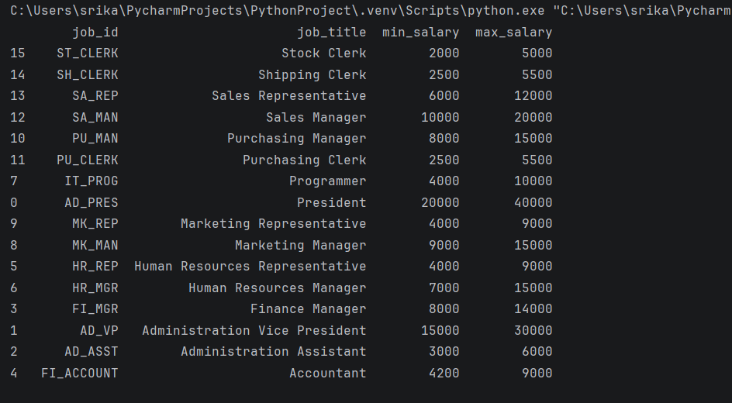
Experiment 4:
Aim: Write a Pandas program to create a line plot of the historical stock prices of Alphabet Inc. between two specific dates.
Python code:
import yfinance as yf
import matplotlib.pyplot as plt
# Download stock data
stock = yf.download("GOOGL",
start="2023-01-01",
end="2023-06-30")
# Line plot
plt.figure(figsize=(10,5))
plt.plot(stock.index, stock["Close"], linewidth=2)
plt.title("Alphabet Inc. Historical Stock Prices")
plt.xlabel("Date")
plt.ylabel("Closing Price ($)")
plt.grid(True)
plt.show()
output:
